Report to the Technical Working Sub Group on the influence of wind speed on emissions and the reduction in measured emissions during mid morning at Santon

Using the R Software a number of Diurnal Plots have been created using data captured at the Low Santon monitoring station. The monitoring period under consideration is 01/01/2006 to 31/12/2009. The hourly profile has been plotted for each day, PM₁₀ and wind speed follow an almost identical pattern increasing from 6am through to 3pm where a sharp decrease is observed. It is important to determine whether wind speed is a major factor in the increased PM₁₀ concentrations at Low Santon. D. Carslaw suggested that if GMT and BST data were plotted together, then should the concentration data shift by one hour we would be able to eliminate wind speed as a major influence on concentration.

After plotting GMT and BST an almost exact one hour shift can be seen. The effect of the clocks going forward is that non-continuous plants operating only in the day-time effectively begin one hour later in the summer months. Atmospheric processes would remain unaffected by the clock change and follow the same patterns throughout the year regardless of the shift to BST.

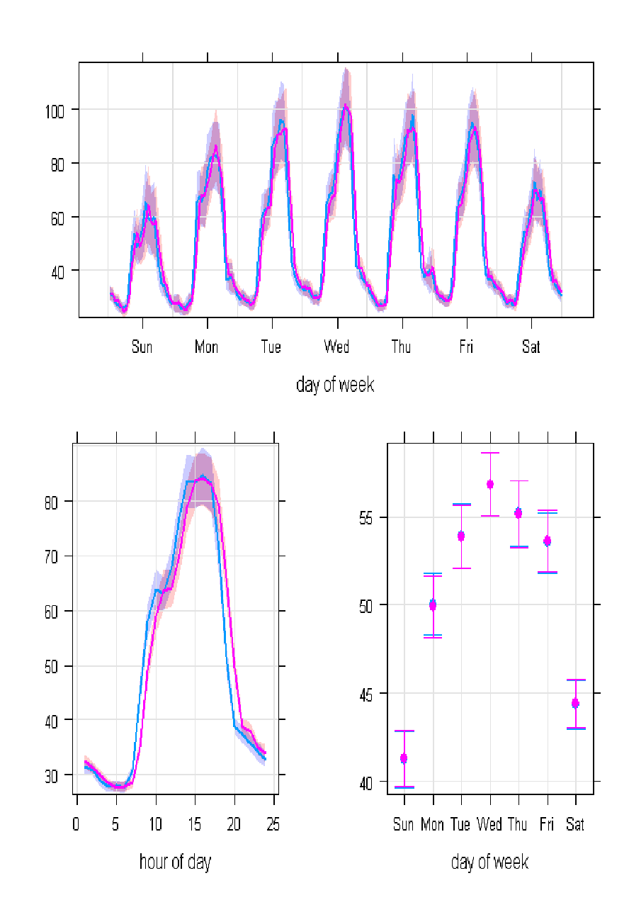

GMT
BST

The one hour shift highlighted a drop in concentration between 10:00am and 11:00pm (GMT). The presence of this reduction in both time scales suggests that this may be process related. North Lincolnshire Council undertook an exercise using the Diurnal Plot tool to plot captured data from the Low Santon monitoring station in 10 degree sectors. These plots are available on request. The plots were studied for similar reductions in mid morning concentrations. Two sectors were singled out as showing similar patterns;

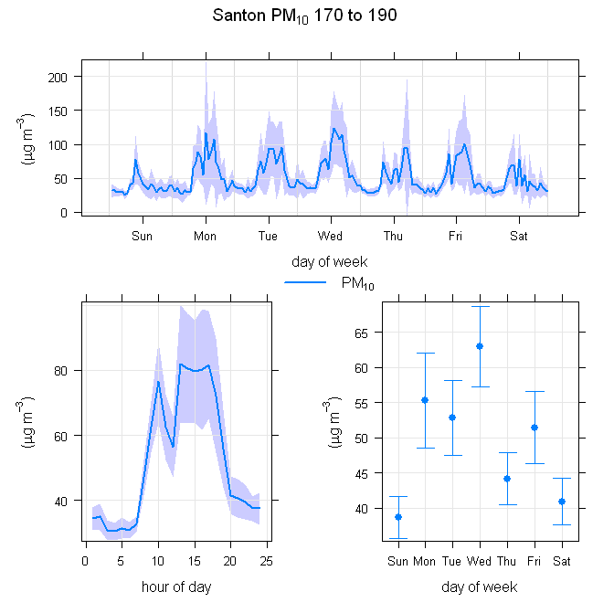

The areas between 170° & 190° and 210° & 240° away from Santon were both subject to noticeable reductions between 10:00am & 11:00am (GMT).

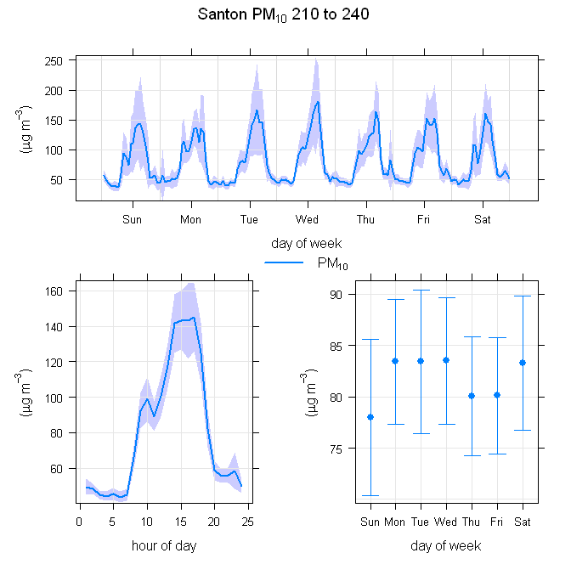

The area between 170° & 190° incorporates a number of activities likely to be contributing to the higher concentrations at Low Santon. These include;

- Tarmac operations at the Yarborough Site
- Multiserv Metal Recovery Plant
- BOS Plant

The area between 210° & 240° also covers a number of activities likely to be contributing to the problem;

- Tarmac and Multiserv operations at the Intermediate Site
- Redbourne Site
- OPP
- Blast Furnaces
- Sinter Plant

Due to the nature of the Diurnal Plot tool, it is difficult to quantify the actual concentrations involved. Below is an excel plot of the mean hourly PM₁₀ concentrations at Santon for reference.

The levelling in concentration mid-morning appears to be earlier than the Diurnal plots suggest. The excel graph using the same data shows a levelling at between 9:00am and 10:00am although the hour shift between GMT & BST remains the same.

The effect of this mid-morning event is a marked slow down in the standard day time increase at Santon. 9.00am & 10:00am record concentrations of 65µg/m³ before the levels return to the same rate of increase as early morning and the start of work.

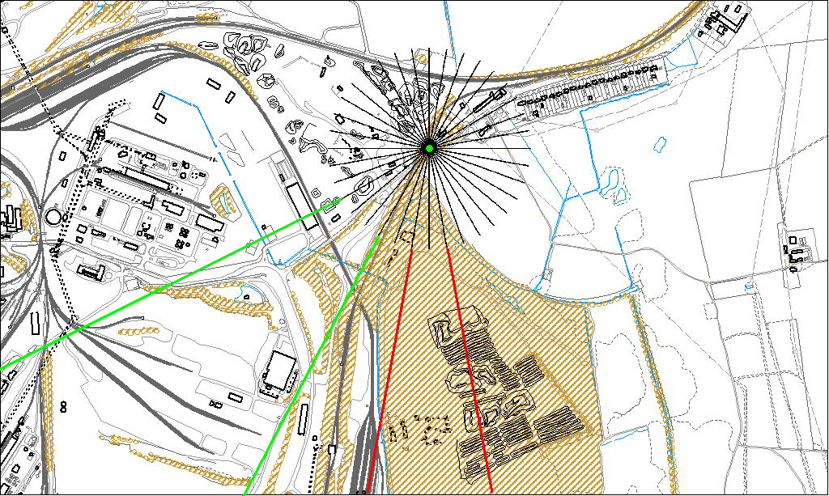

It is important to investigate which areas of plant and equipment stop or reduce activity mid-morning. Using the Diurnal Plots it is safe to assume that these areas make a significant contribution to the problems at Low Santon. Should specific equipment be identified as stopping around these times a review of their operation could make a major difference in the number of daily exceedances currently being witnessed.

In order to progress this theory it would be useful if process operators could assess relevant process areas to determine what might meet the above profile. I would ask therefore that Corus report back at the July meeting of the sub group. In the interim I intend to discuss this report with Tarmac Ltd and would ask the EA to do the same with Muliserv.

Ross Thomson
Technical Officer – North Lincolnshire Council
19th May 2010

